Squeeasy Bill of Materials:

Company Name: | LEA Sports Ltd. | Version: | 2
Date: | 05/02/2024 | Project Number: | 843

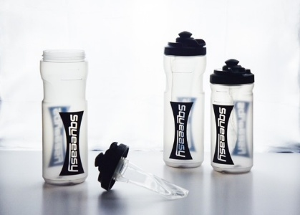 | Part Number | Description | Part picture |  | Material / Specification | Material Name
 | 843-SQZ-008/9 | Bottle | 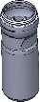 | Not tinted  Food grade (0.0g black pigment per kg) | PP | Topilene R301
 | 843-SQZ-006 | Pouch fitting | 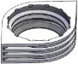 | Clear | TPU | Empilon 9793
 | 843-SQZ-007 | Pouch side |  | Clear | TPU | SQ396 EXT F 87
 | 843-SQZ-001 | Lid |  | Black | PP | PP 5090T
 | 843-SQZ-002 | Switch |  | Black | PP | PP 5090T
 | 843-SQZ-003 | Valve seal | 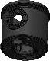 | Black | Silicone 50 shore | Silicone 6250
 | 843-SQZ-004 | Mouthpiece |  | Black | Silicone 60 shore | Silicone 6250
 | 843-SQZ-005 | Umbrella valve |  | Black | Silicone 50 shore | Stock Part - JT1134-5

